Committed used discount: when you use a vm for 1 or 1-3 years then you get more discount

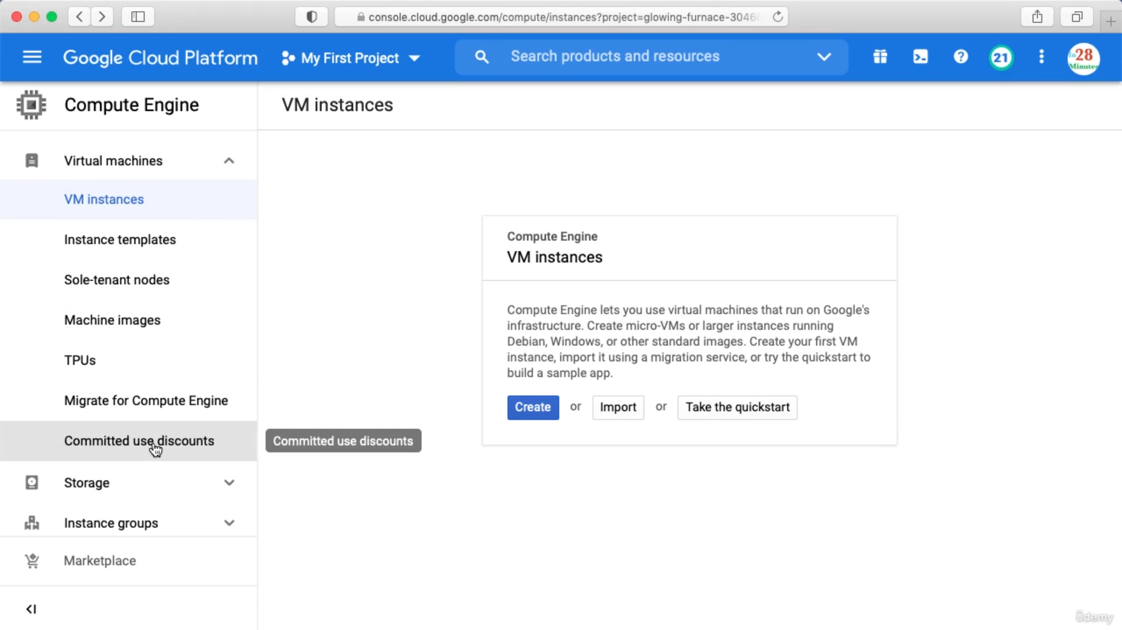

Here you can purchase commitment

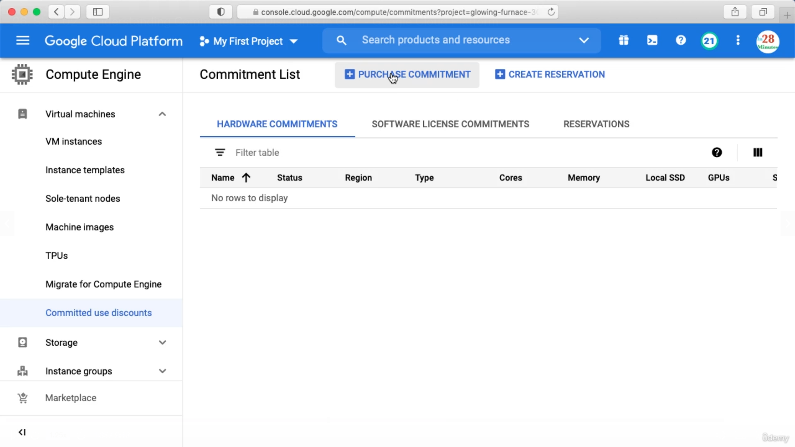

When you purchase a commitment and create instance of that type, discount is automatically applied.

You can specify a VM as preemptible while creating VM in the below section under management. This does not fall under free tier.

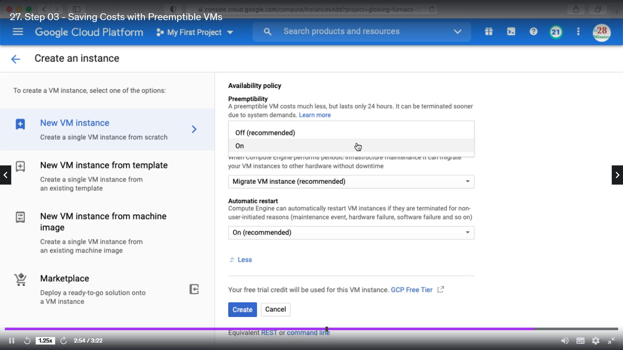

Spot VMs are the latest version of preemptible VMs.

Creating Budget Alerts

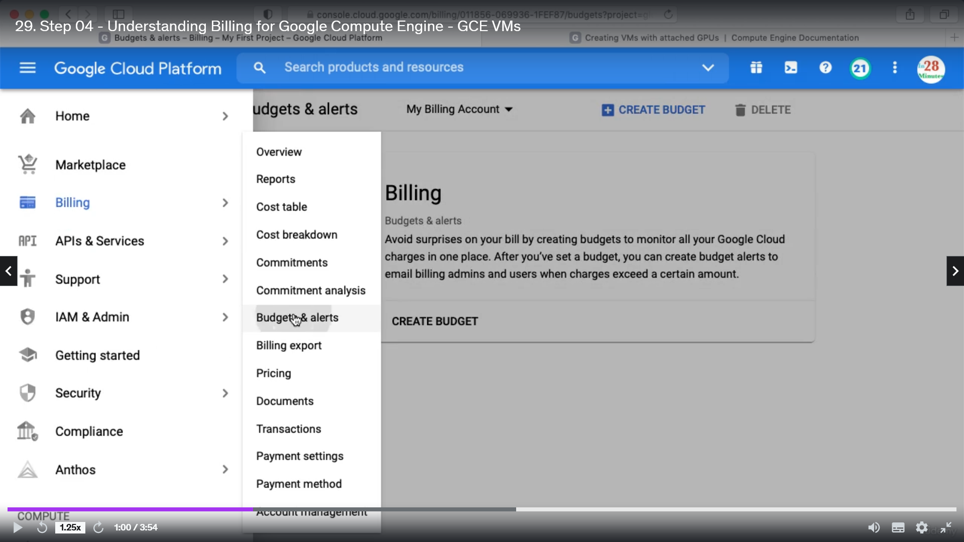

Click Budget & alerts and create budget, give a name and click next

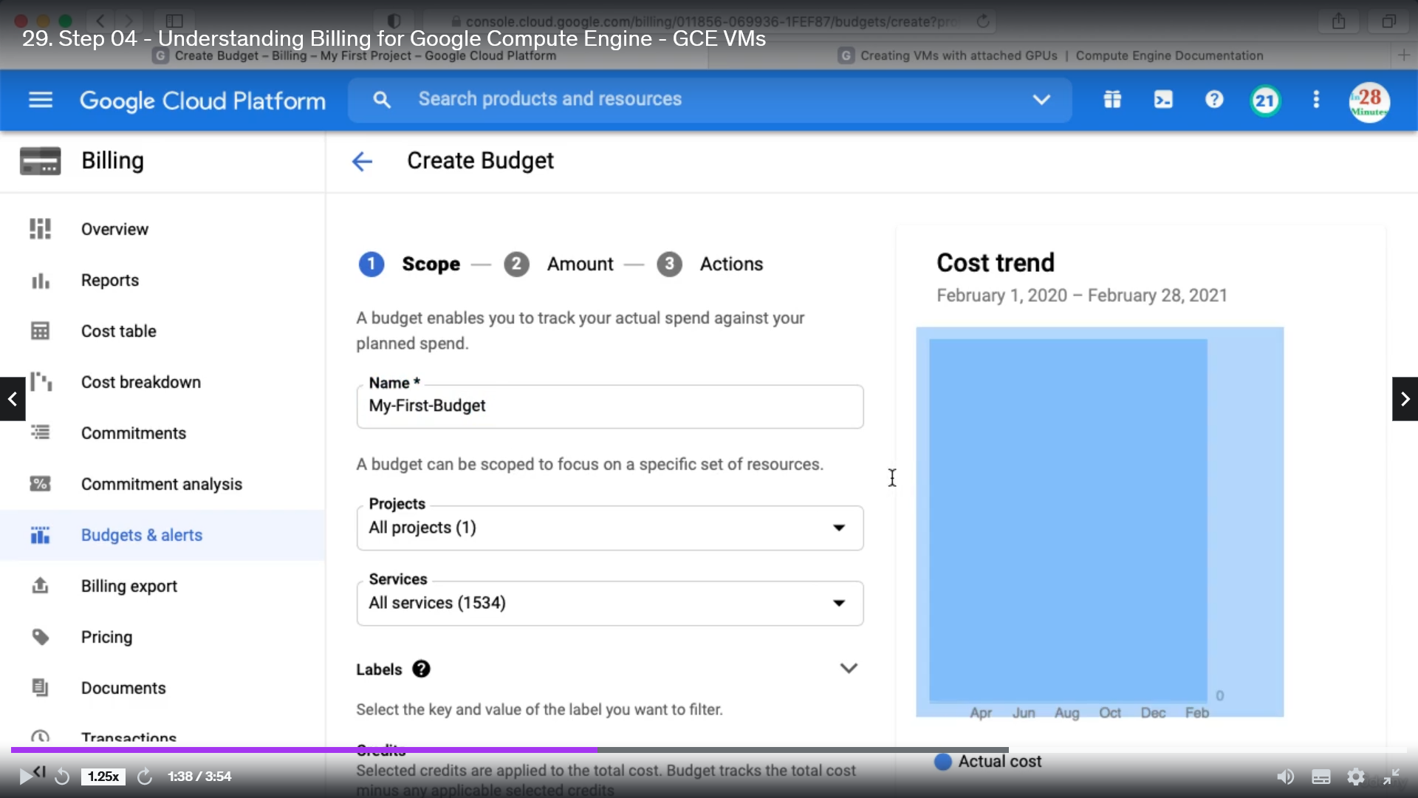

Specify a target amount

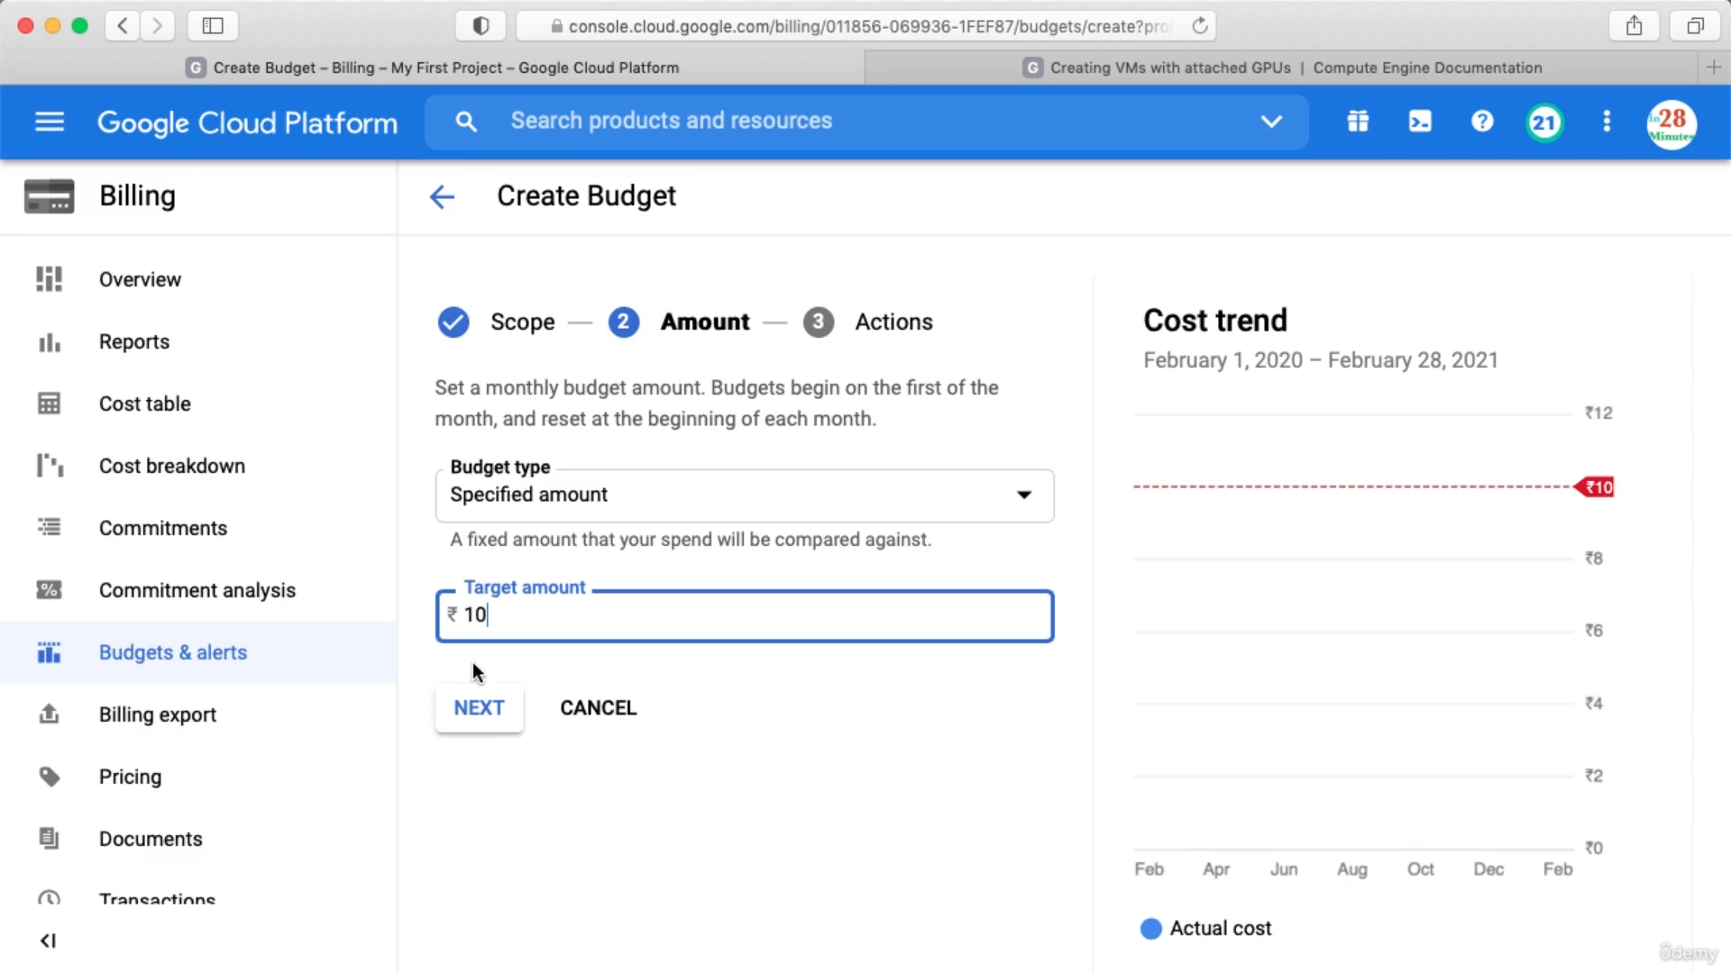

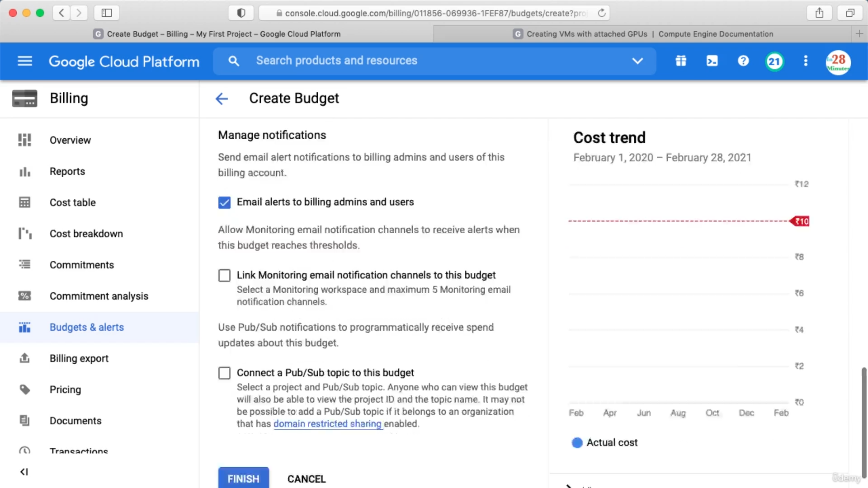

Make sure you check above and click finish.

Billing Export

You can take the billing and export it to a number of services. Ex: you can send billing details to BigQuery data set.

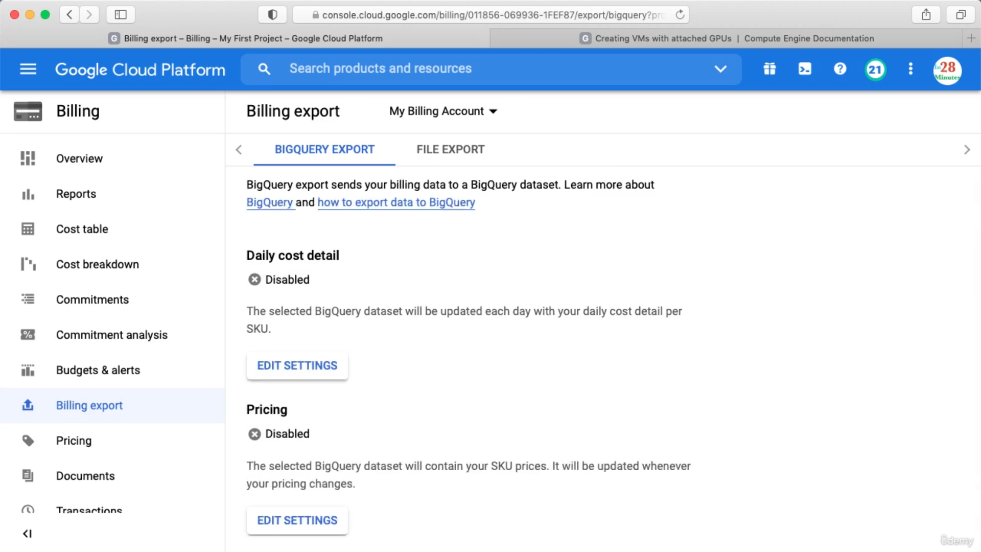

While creating instance you can Select availability policy as below

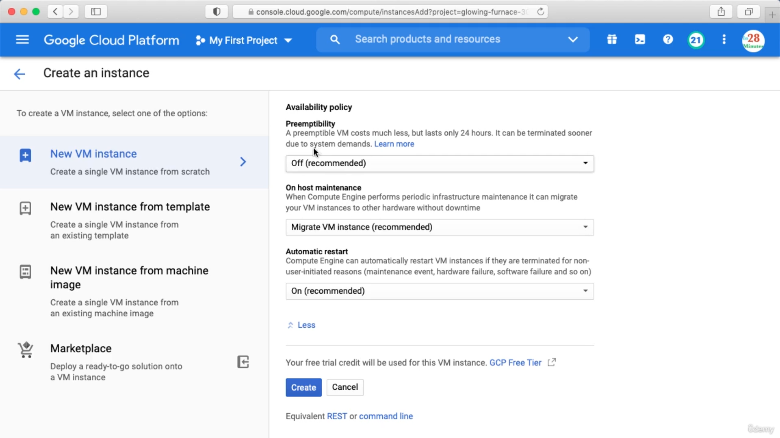

Creating Custom machine => while creating vm you can select Machine type as below

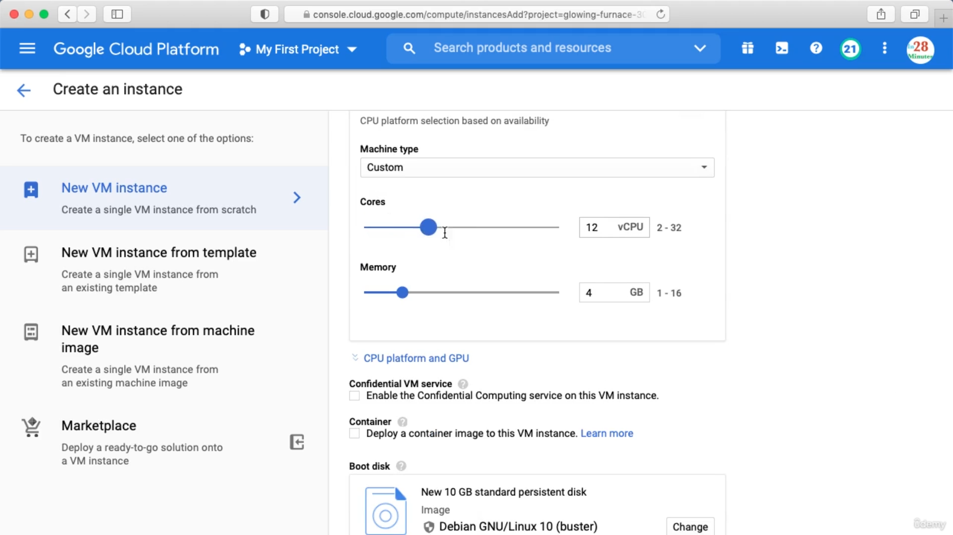

GPU = Graphic processing unit

Creating GUP System

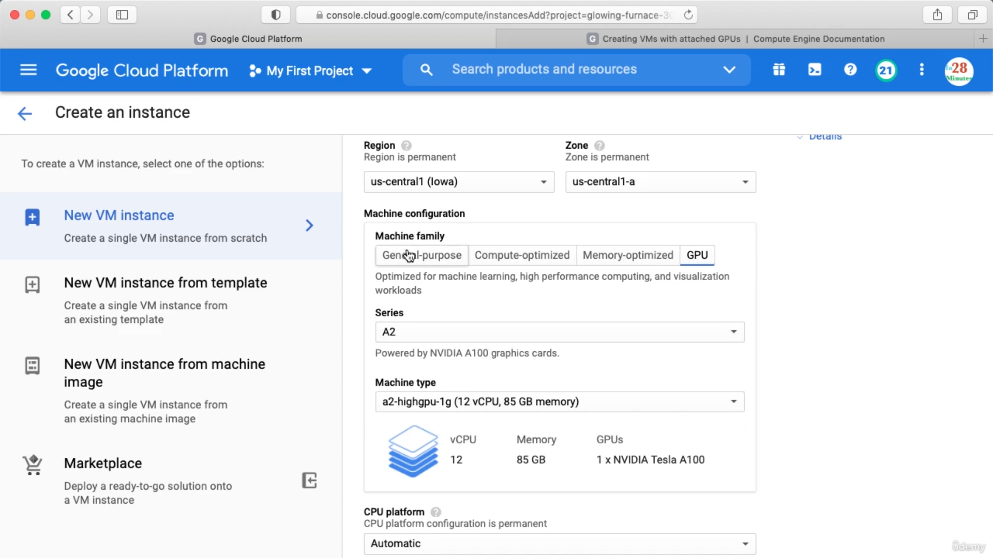

Another way

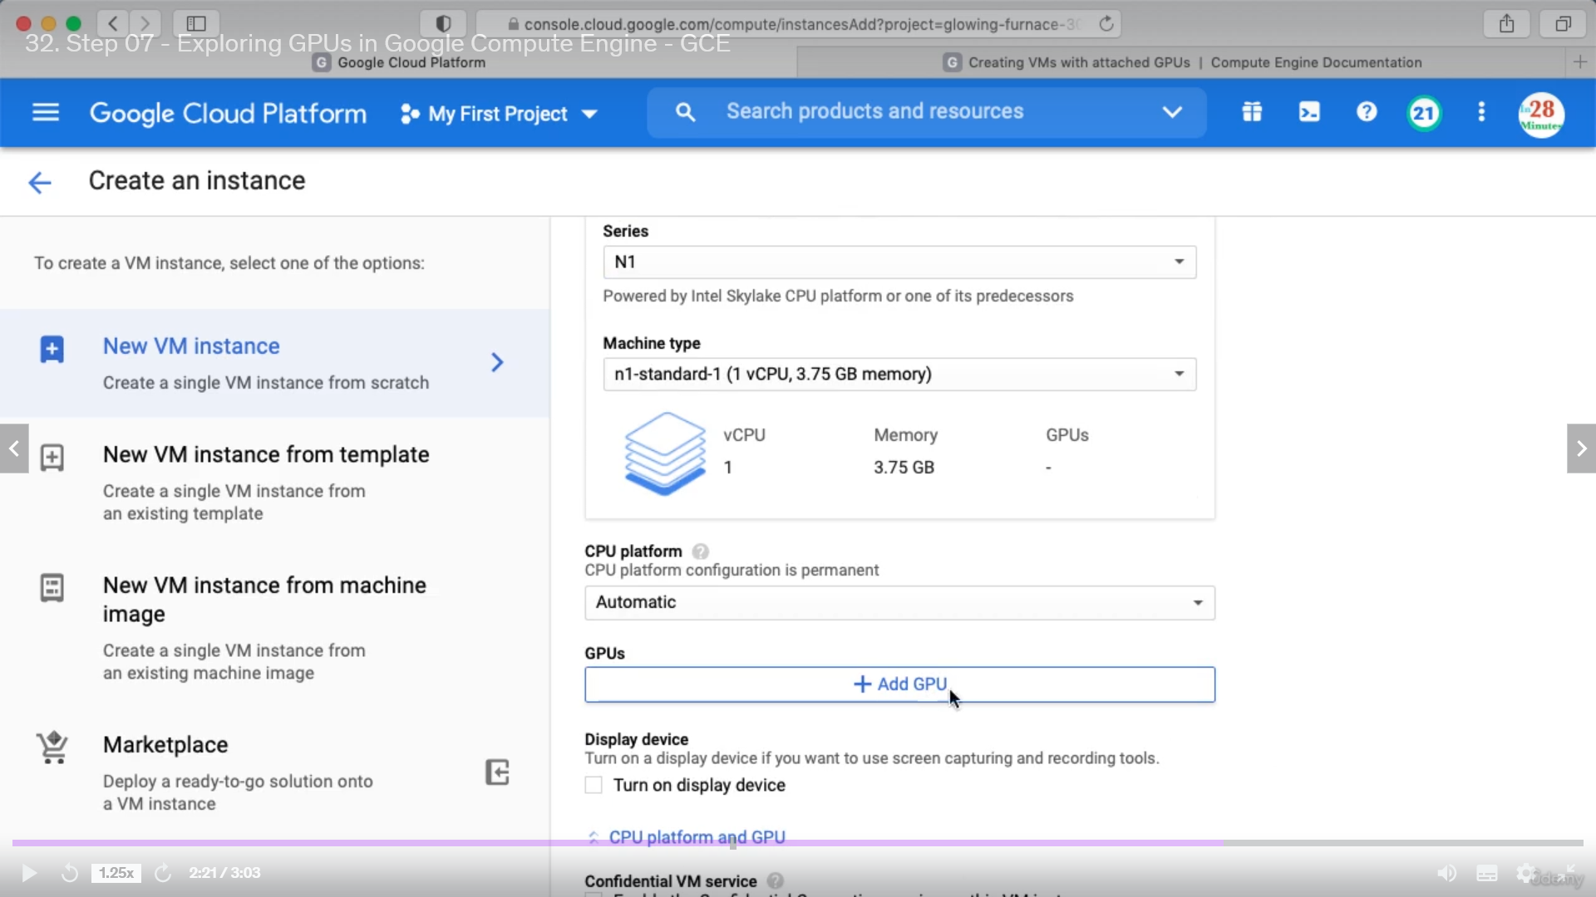

Select Specific Series and then add GPU.

Monitoring in your VM

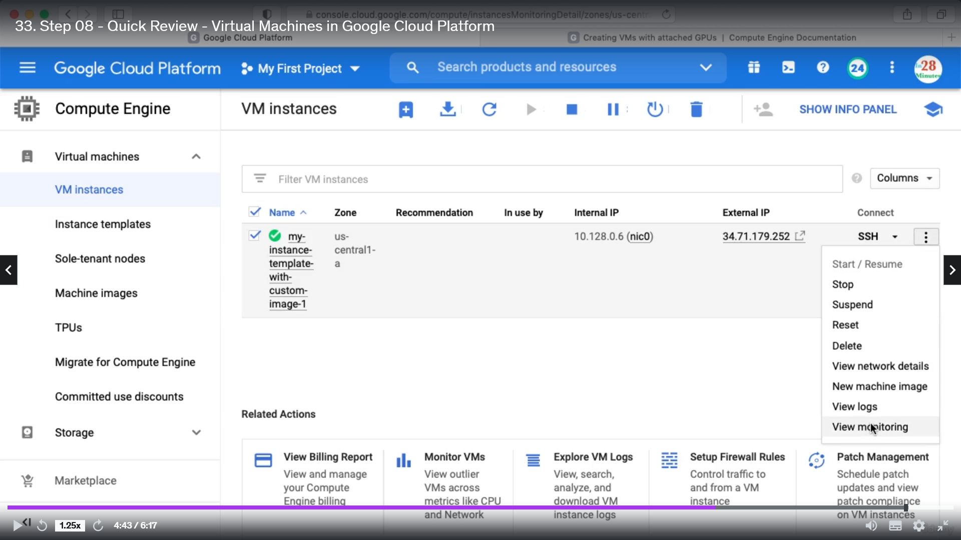

For every project we need to enable compute Engine API

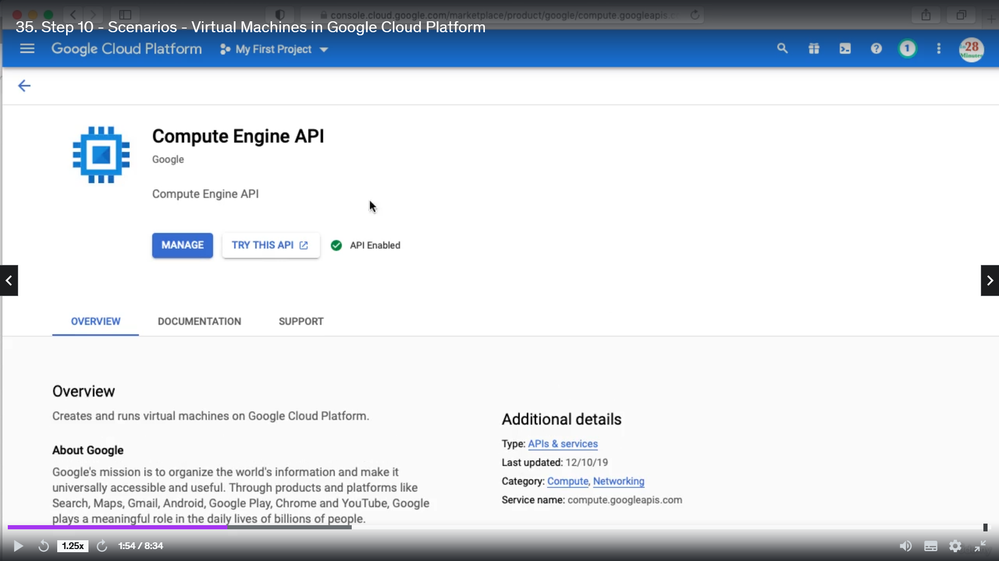

Also there is a default billing account created when we sign in.

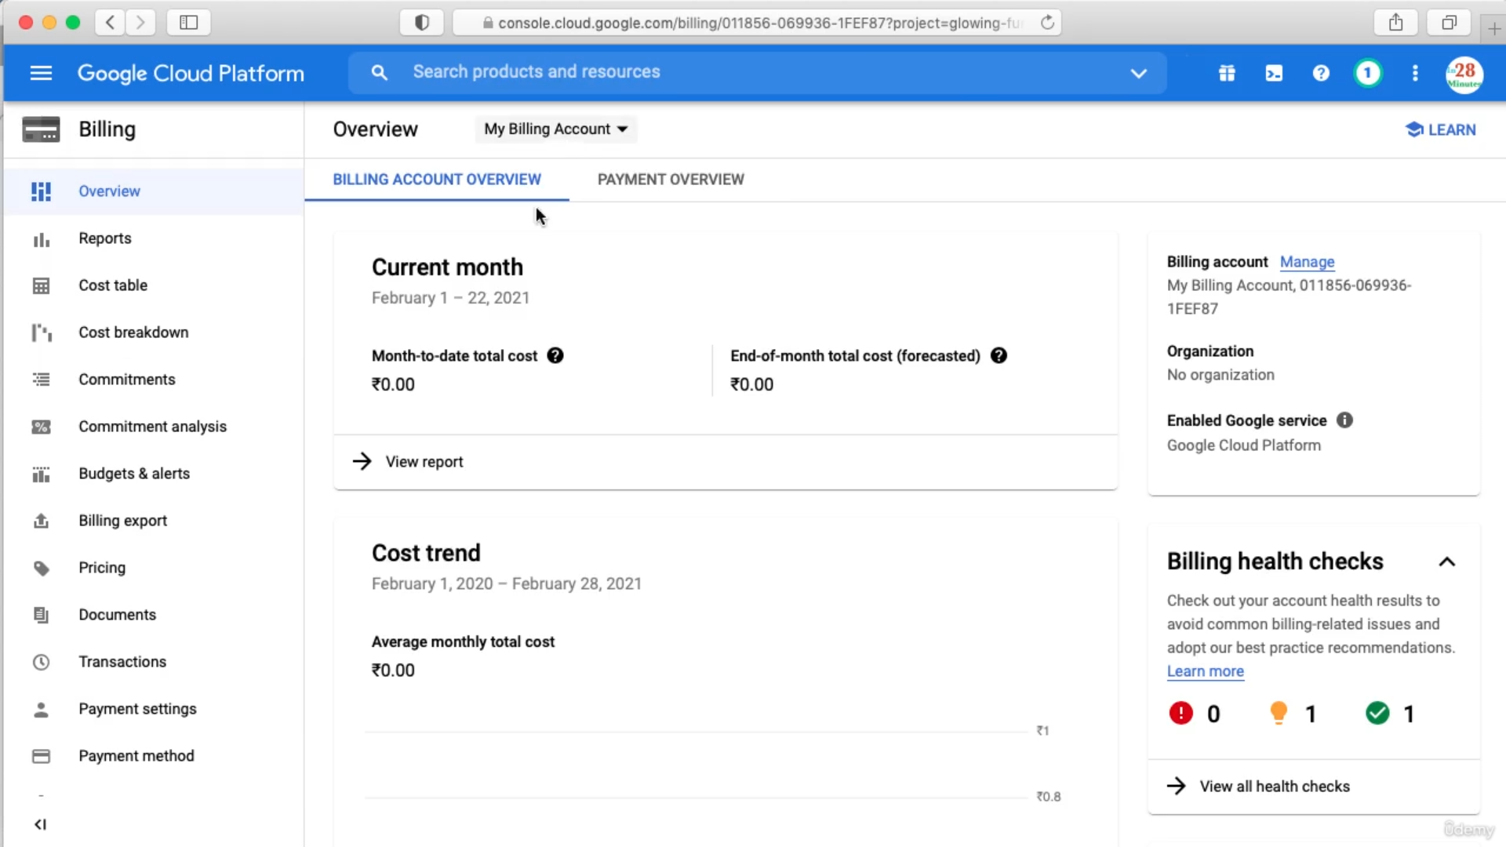

Bydefault the hardwares provided for an instance is distributed, now if you want to have specific hardware for your vm only then go to Compute Engine => sole-tenant

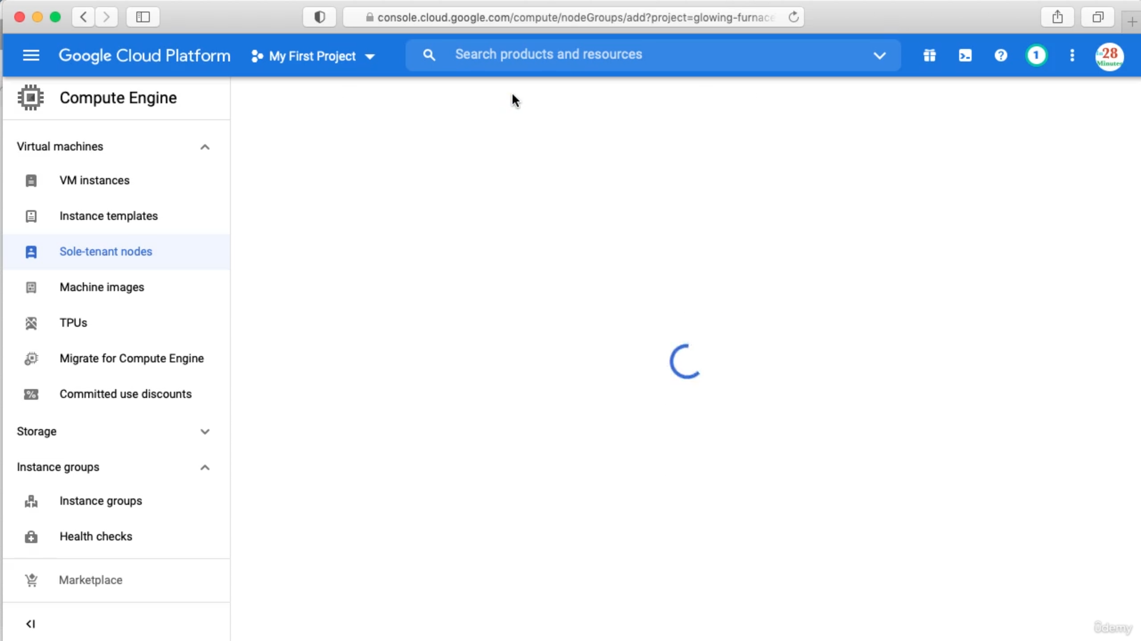

First you need to create a node group

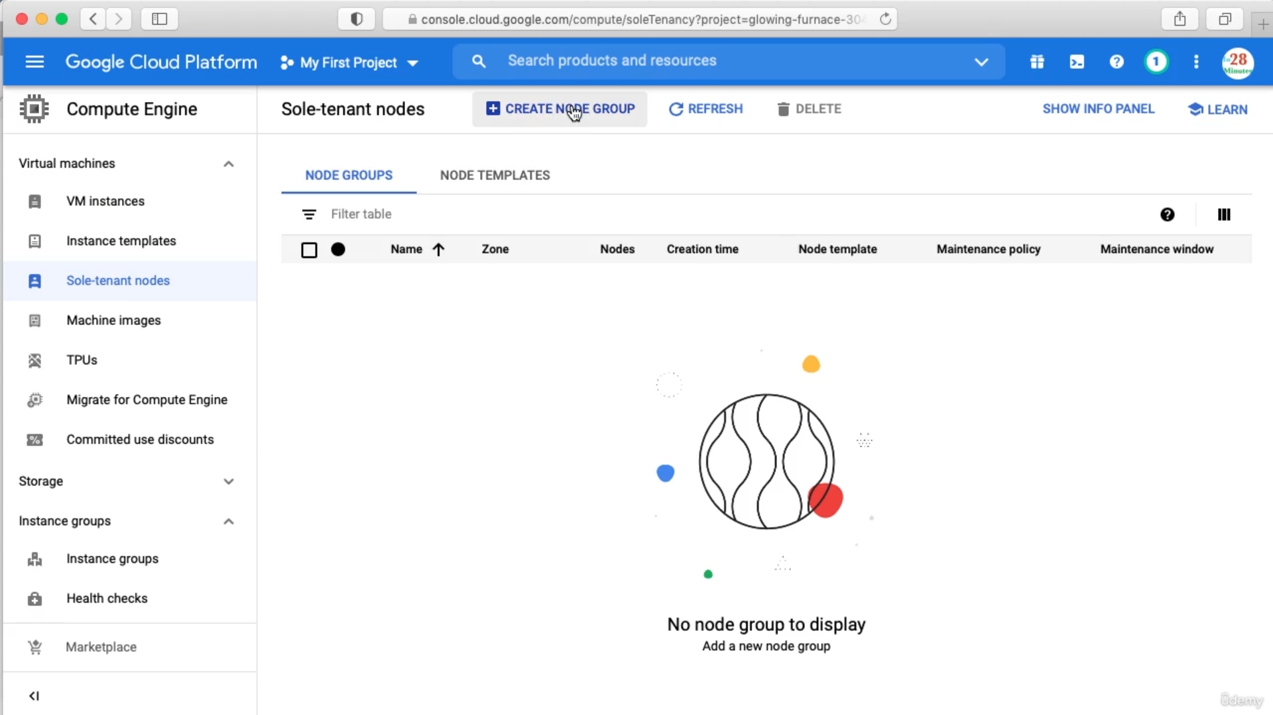

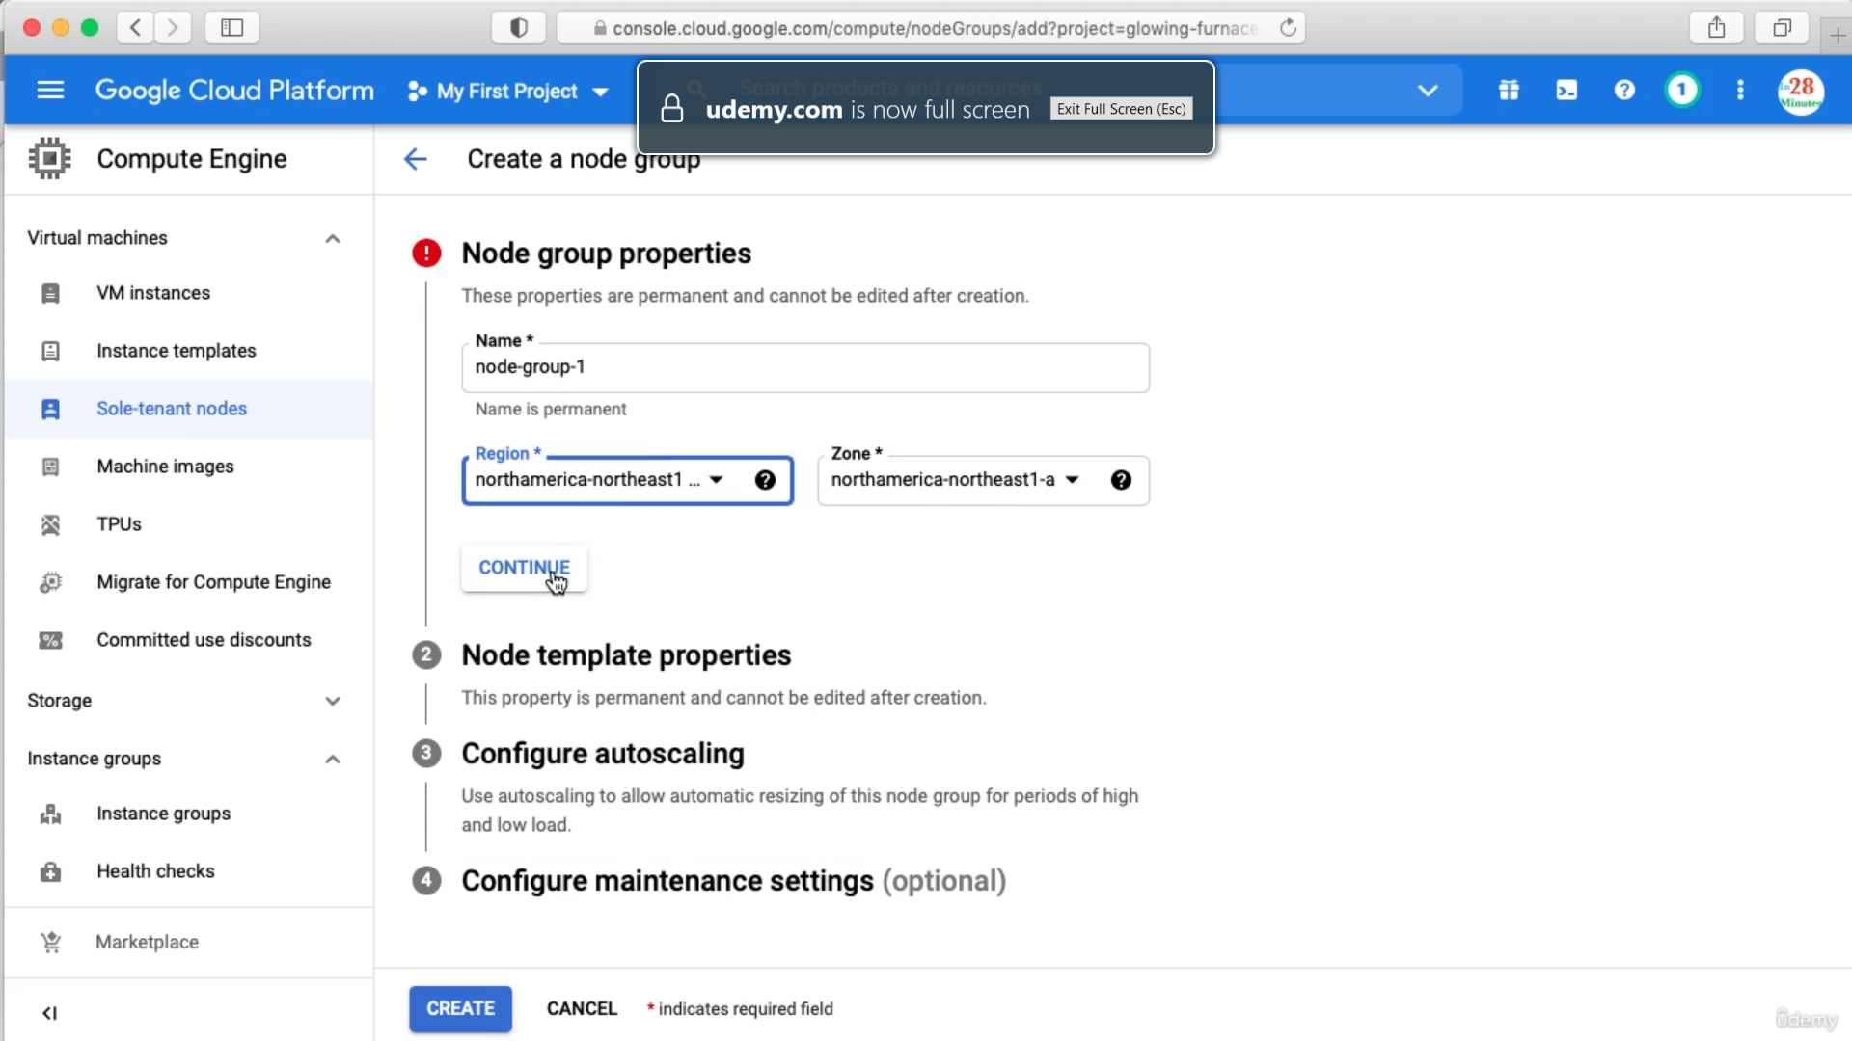

Next we need to create a Node Template

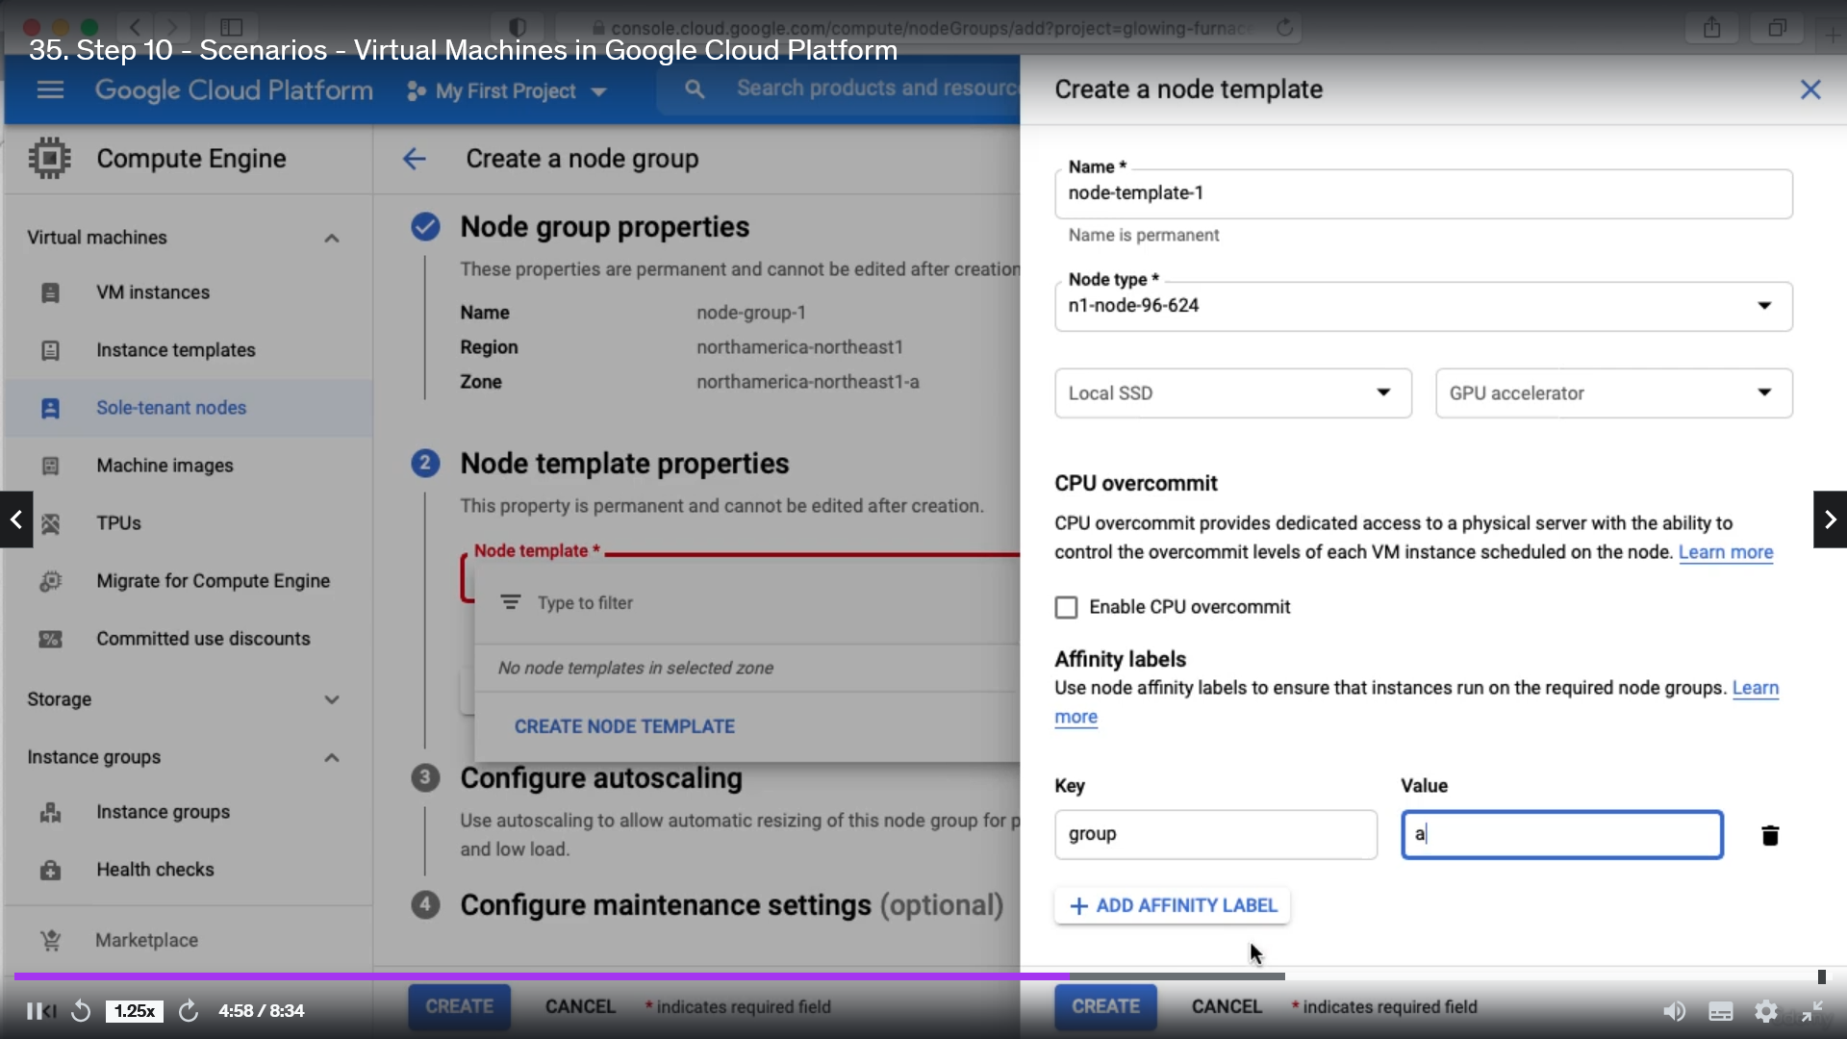

We will not create this as this is very expensive.

While creating VM we can specify Sole-tenant node as below. Using the key and value.

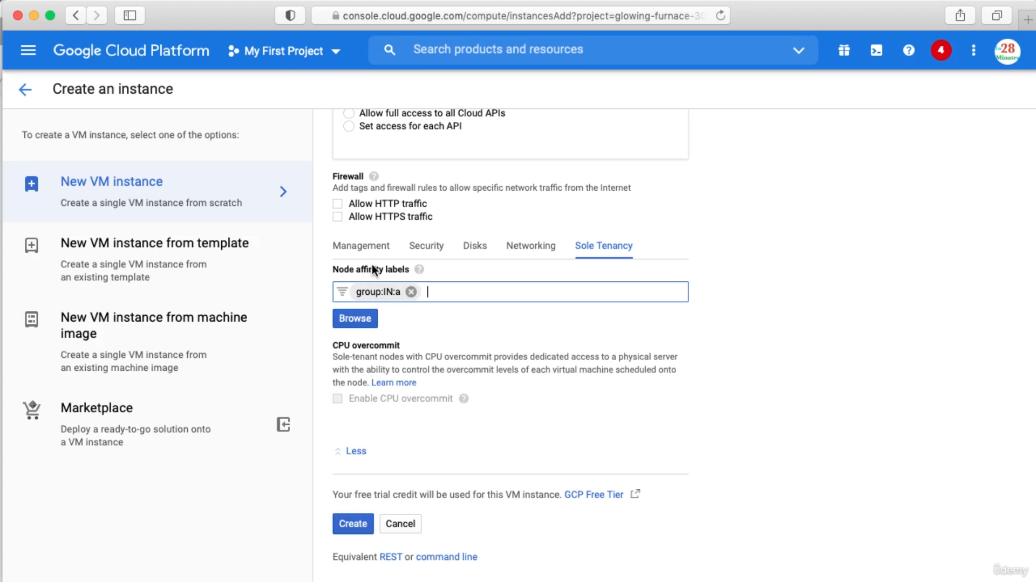

VM Manager

